Assignment: Vessel Hire & Market Dashboard with Login

Objective

Build a mini full-stack app with Django (backend), MS SQL Server (database), and React (frontend). The app should:

1. Support user login (basic authentication).
2. A window for admin to put data .
3. Display hire & market rates for vessels on a graph after login.

Requirements

1. Backend (Django + MS SQL Server)
   * Connect Django to MS SQL Server.
   * Implement authentication using Django’s built-in User model:
     + POST /api/login/ → returns an auth token (JWT or session-based).
     + Protect all data endpoints (require login).
   * Define a table vessel_data with:
   * id (int, PK, auto)
   * vessel_name (varchar)
   * date (date)
   * hire_rate (int)
   * market_rate (int)
   * Seed at least 3 vessels with 30 days of data.

1. Frontend (React)
   * Create a login form (username + password).
     + On success, store the token/session in localStorage. oRedirect user to the dashboard.
   * Dashboard features:
     + Dropdown to select vessel and date range. oFetch data from Django API using the stored token.
     + Display line chart (Recharts):
       - X-axis: Dates
       - Y-axis: Hire Rate (yellow line), Market Rate (blue line).
       - Tooltip on hover showing exact values.

1. Bonus (Optional)
   * Add an Admin-only view with aggregated graph (sum of hire & market rates across all vessels per day).
   * Deploy using Docker Compose (Django + React + MS SQL containers).
   * Add role-based access (e.g., Admin vs. User).

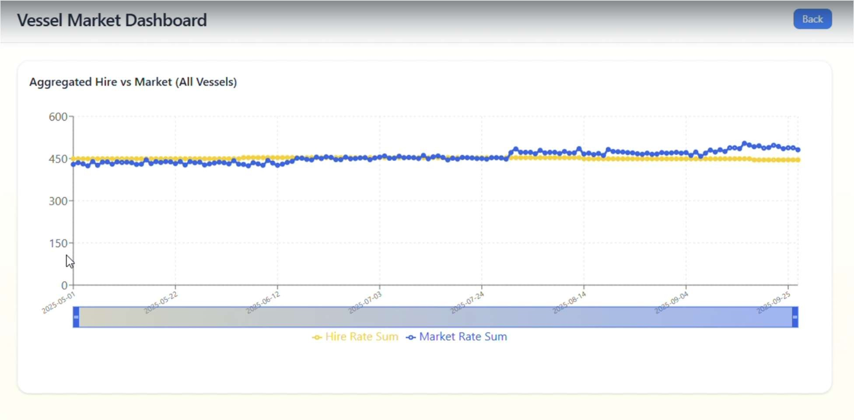

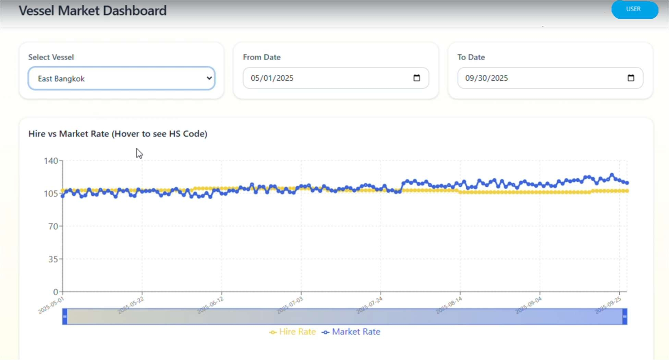

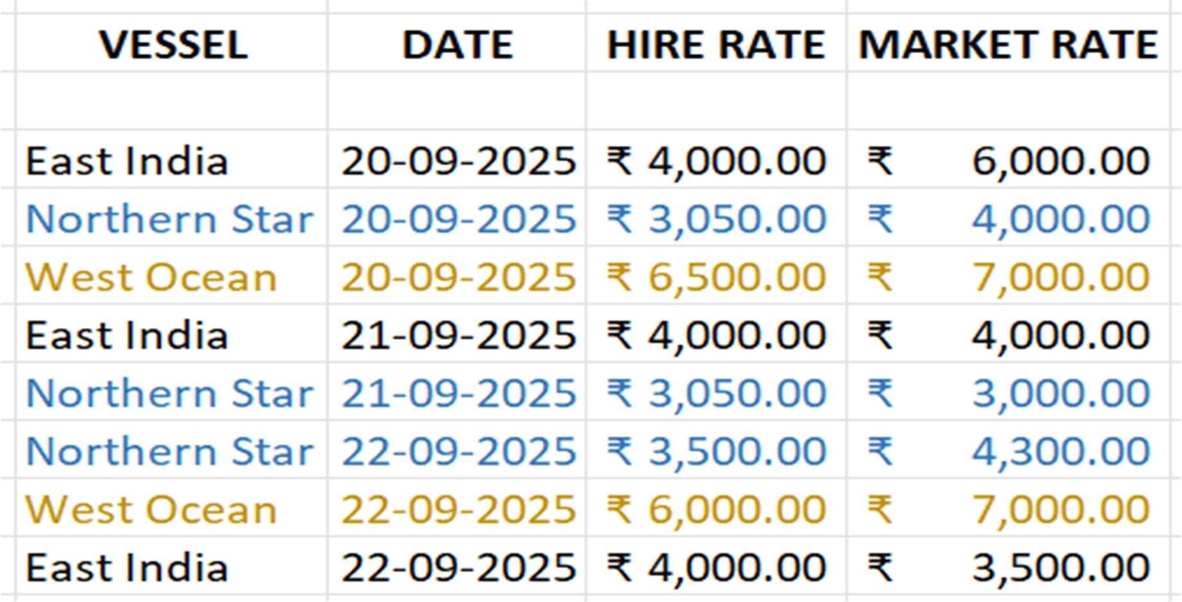

|  |  |  |
| --- | --- | --- |
| Dashboard |  |  |
| User |  |  |